Project 21

Drag and Drop
Drag and drop can be a method be which objects can be selected within an application program. The use of drag and drop can be quite diverse. It is possible to drag from say a picture to a label and to use only some text from the picture object.

Program Appearance
The layout of the application used to demonstrate the drag and drop event is in the screen shot shown below. The form contains the following items.
- Picture Box named PictureSelected.
- Image Box named ImageSelected.
- Two labels named LabelSelected and LabelPrompt.
- A control array of ten Picture boxes with ten pictures loaded in to each.

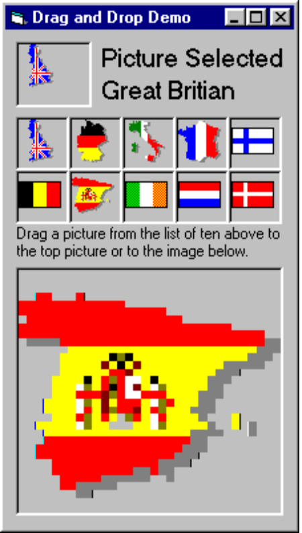
The array of ten pictures have the Drag mode property set to Automatic and have the Tag property set to a piece of text that will be used by the application. The Image has its stretch property set to true.

Code to achieve the result.
The code that is required to make the dragged object copy its appearance is very little. There are principally three actions that take place within the Drag Drop event for the image and picture. In each case these are the same actions.
- Check the source object is a PictureBox.
- Copy the Picture from the source to destination object.
- Change the label to “Selected “ plus the text stored in the tag property of the source picture box.
If the drag mode property of the image and picture is set to automatic, then when you drag the pictures they drag. You will notice that you will only be able to copy the Pictures to the image and not the Image back to the picture.
Option Explicit
Private Sub ImageSelected_DragDrop(Source As Control, X As Single, Y As Single)
If TypeOf Source Is PictureBox Then
' Set Picture bitmap to same as source control.
ImageSelected.Picture = Source.Picture
Labelselected.Caption = "Image Selected" & vbCrLf & Source.Tag
End If
End Sub
Private Sub Labelselected_DragDrop(Source As Control, X As Single, Y As Single)
If TypeOf Source Is PictureBox Then
ImageSelected.Picture = Source.Picture
PictureSelected.Picture = Source.Picture
Labelselected.Caption = "Both Set to" & vbCrLf & Source.Tag
End If
End Sub
Private Sub PictureSelected_DragDrop(Source As Control, X As Single, Y As Single)
If TypeOf Source Is PictureBox Then
' Set Picture bitmap to same as source control.
PictureSelected.Picture = Source.Picture
Labelselected.Caption = "Picture Selected" & vbCrLf & Source.Tag
End If
End Sub

Exercise
Write a program that will select items from a list box by the drag and drop method. The list box item should be added to an additional list box and list produced of the number of items added for each of those different items.
The program can be one that is to control any list of your choice. Some ideas for list follow.
- Football teams.
- Store room parts
- Countries or towns
- CD selection
- Tracks from a CD.

